School: Tan Tien Primary school  Full name: ………………………  Class: 5 …… | THE FIRST SEMESTER TEST  ENGLISH – GRADE 5  SCHOOL YEAR: 2020 - 2021  Time: 35 minutes

Marks | Listening | Reading | Writing | Speaking | Total
Remark | …………………………………………………………………………………………………………………………………………………………

PART I. LISTENING (2.5pts)
Question 1. Listen and tick. There is one example. (0,75 point)

0.
a. | b. | a. | b.
2 |  | 3.
a. | b. | a. | b.

Question 2. Listen and number (1 point)
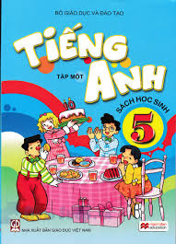 | 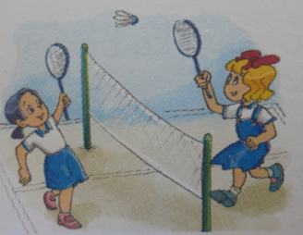
a. | b. | c. | d.

Question 3. Listen and complete. There is one example (0,75point)
Phong: I didn’t see you yesterday.Where did you go?
Mai: I went to the (0) zoo .
Phong: What did you see at the zoo?
Mai: I saw a baby (1)______________ and some other animals .
Phong: Did you see any(2)___________________?
Mai: Yes,I did.They were really noisy!
Phong : Did you see any __________________ (3) ?
Mai: Yes .They were really fast.
PART II. READING (2,5pts)
Question 4. Read the text carefully. Tick () YES or NO.
Our school Sports Day will be next month.Everyone in my class is going to take part in it. Nam and Phong are going to play basketball.Tony’s going to play table tennis and Lan’s going to play badminton.Long and Quang are going to play football. Ha’s going to run a hundred metres.Minh is going to watch them because his legs was broken. My classmates are practising hard for the events. We hope that we will get the first prize.
 | Yes | No
- Sports Day will be next week.
- Ha and Lan are going to take part in Sports Day.
- Minh is going to play basketball.
- All the students hope that they will win the competitions.
- Tony’s going to play tennis.
Question 5. Read and match descriptions with words.
 | 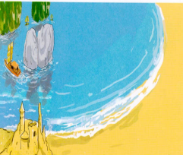 |  |  | 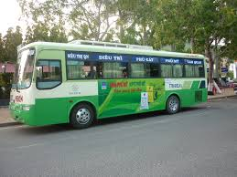
a.apple | b. in the sea | c.basketball | d. morning | e. school bus | f. bicycle

0. It’s a kind of fruit. a. apple

1. It’s a sport . _________
2. It takes us to school. _________
3. Time you have breakfast. _________
4. Where you can swim. _________
5. Students ride them to school _________
PART III. WRITING (2,5pts)
Question 6. Look at the pictures. Look at the letters. Write the words. There is one example (0,5point)
0. S c o o l h |  | ____School ___
1.a l p e n |  | _ _ _ _ _
2. p e c a o c k |  | _ _ _ _ _ _ _

Question 7. Read and write the word in each gap.There is one example. (1point)
0. | 0. What do you do in the morning?  ->I ride my bike to the park.
 | 1.My brother went to Hue by ................ .
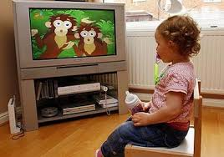 | 2. I learn English by................................... cartoons on on TV.
3.What are you reading?
I’m reading .....................................and the Seven Dwarfs.
4.Did you go on a ....................................?
Yes, I did.
Question 8. Reorder the words. There is one example (1point)
0. are/ Where/ you/ from ? Where are you from?
1. saw/I/some/ pythons/at /the zoo.
………………………………………………………………………….
2. English /We/have /a week. /four times
……………………………………………………………………………
3. Phu Quoc Island /went/My family/to /by plane.
……………………………………………………………………………
4. this weekend? /will /Where /you /be
……………………………………………………………………………

PART IV: SPEAKING (2,5 poinst)
Part 1: Getting to know each other (1.0point)
Part 2: Talking about a familiar object (1.0point)
Part 3: Describing the picture (0.5 point)

Họ, tên giáo viên coi, chấm: ..............................................

Answer Key grade 5
Each right answer is 0,25 point
PART I. LISTENING
Question1: Listen and tick.
1.b | 2. a | 3. b
Question 2: Listen and number .
- c | - b | - a | - d
Question 3. Listen and complete
- elephant | - monkeys | - tigers

PARTII. READING AND WRITING
Question 4: Read and tick.
- N | - Y | - N | - Y | - N
Question 5. Read and match.
- C | - E | - D | - B | - f
Question 6. Look at the pictures. Look at the letters. Write the words.
- Plane | - Peacock
Question 7. Read and write the word in each gap
- Car | - watching | - Snow White | - Picnic

Question 8. Reorder the words to make sentences.
- I saw some pythons at the zoo.
- We have English four times a week.
- My family went to Phu Quoc Island by plane.
- Where will you be this weekend?

MA TRẬN ĐỀ TIẾNG ANH LỚP 5 KỲ I – NĂM HỌC 2020-2021
Kỹ năng | Nhiệm vụ đánh giá  kiến thức cần đánh giá | Mức/Điểm |  |  |  | Tổng số câu, số điểm, tỷlệ %
Nghe |  | M1 | M2 | M3 | M4 | 10 câu  2,5 điểm  25%
 | Listen and tick | 1  0,25 | 1  0,25 | 1  0,25
 | Listen and number. |  | 2  0,5 | 2  0,5
 | Listen and complete | 1  0,25 |  | 1  0,25 | 1  0,25
Đọc- Viết | Read and tick | 1  0,25 | 1  0,25 | 1  0,25 | 2  0,5 | 20 câu  5 điểm  50%
 | Read and match |  | 2  0,5 | 3  0,75
 | Look at the pictures. Look at the letters. Write the words. |  |  | 2  0, 5
 | Reorder the words to make sentence |  |  | 4  1,0
 | Read and write the word in each gap |  | 2  0,5 | 2  0,5
Nói | Getting to know each other | 1  0,25 | 1  0,25 | 1  0,25 |  | 10 câu  2,5 điểm  25%
 | Talking about familiar topics |  | 1  0,25 | 2  0,5 | 1  0,25
 | Describing picture  What did they do/ Where did they go….? |  | 1  0,25 | 1  0,25 | 1  0,25
Tổng |  | 4  10% | 12  30% | 18  45% | 6  15%

